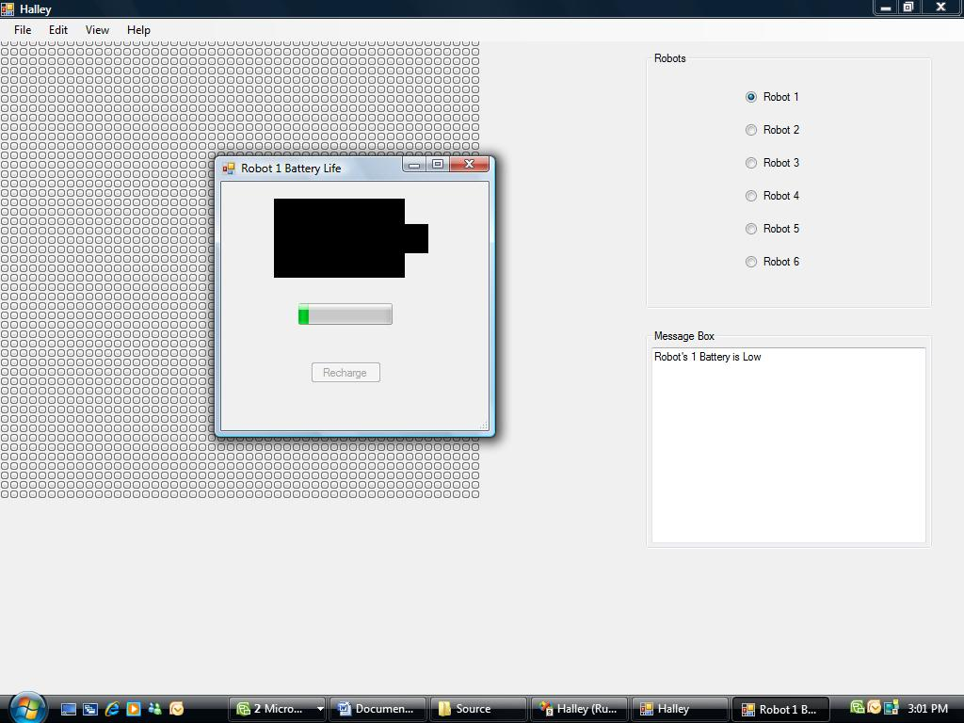

This is illustrating that robot 1’s battery is low and will alert you via the message box.

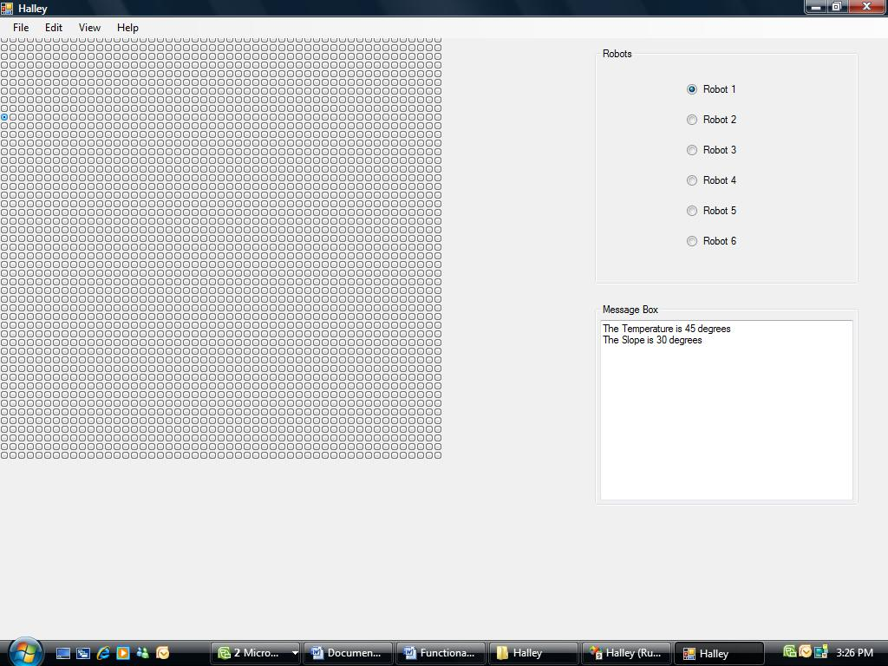

This picture is showing the temperature and the slope in the message box. Given where the current robot is postioned.

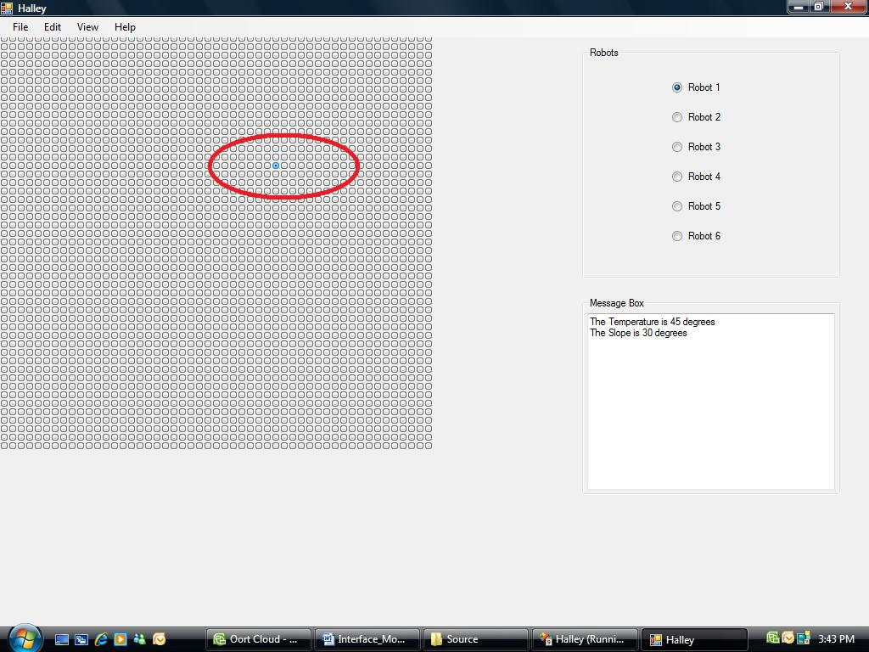

Circled is red is the robot’s current position this can be changed by moving the arrows keys on the keyboard.

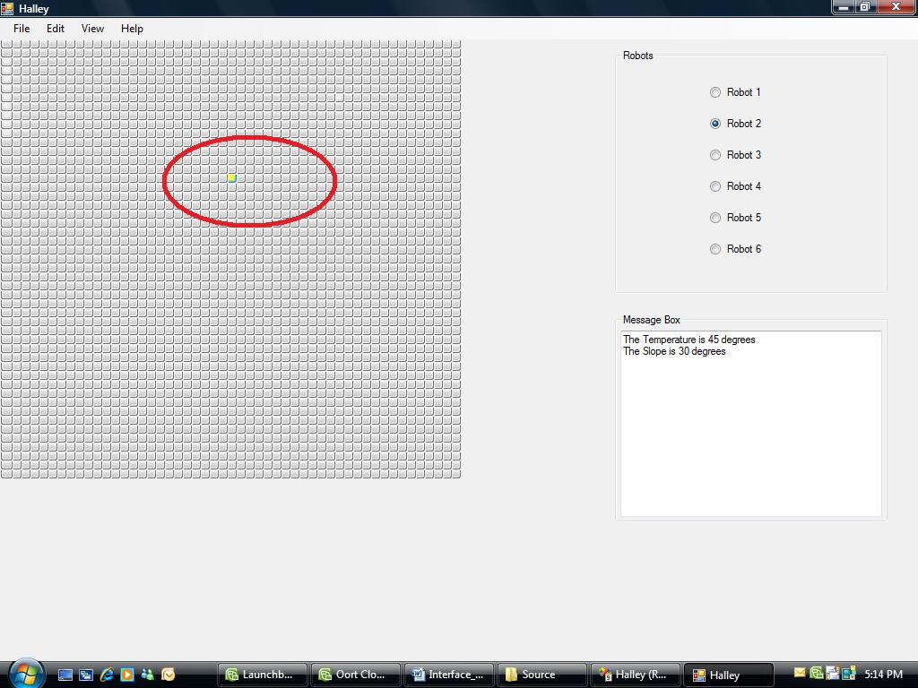

This demonstrates the different color of the robots when they are selected.